**Lab Manual- Route Blob storage events to Service Bus Queue endpoint with the Azure portal**

**Prepared for**: TechPledge

**Date:** 18th Nov 2018

**Prepared by:** Shruti Sinhaa

Document Name: Lab Manual

**Document Number** DevOpsLab401

**Contributor:**

Bipin Sinhaa

Table of Contents

1 OBJECTIVE 3

2 PRE-REQUISISTE 4

3 Lab Scenario 4

4 Setup the Enviornment 5

4.1 **Create a Service Bus Namespace and Queue** 5

4.2 **Create a queue in the Service Bus** 6

4.3 **Create a Storage Account and Blob Container** 7

5 Setup the Event Subscription 8

6 Trigger the Event with Blob Upload and Delete operation 11

# OBJECTIVE

Microsoft Azure offers four services for messaging and events in Azure: Service Bus, Storage Queues, Event Hubs, and Event Grid.

|  |  |
| --- | --- |
| **Messages** | **Events** |
| A message is raw data produced by a service to be consumed or stored elsewhere. | An event is a lightweight notification of a condition or a state change. |
| The publisher of the message expects how the consumer handles the message. | The publisher of the event does not expect how the event is handled |
| For example, A file sent as a message containing the data. | For example, An event notifies consumers that a file gets created. It may contain general information about the file but might not have the file itself. |

**Which service to use and When?**

|  |  |  |  |
| --- | --- | --- | --- |
| **Service** | **Purpose** | **Type** | **When to use** |
| **Event Grid** | Reactive programming | Event distribution (Discrete) | React to status changes |
| **Event Hubs** | Big data pipeline | Event streaming (Series) | Telemetry and distributed data streaming |
| **Service Bus** | HHigh-value enterprise messaging | Message | Order processing and financial transactions |
| **Storage queue** | Standard queuing scenarios, load leveling, and building process workflows | Message | Applications which need to store large sizes of messages in a queue. |

**Azure Service Bus**

Azure Service Bus is a **messaging service on the cloud**, used to connect any applications, devices, and services in the cloud to other applications or services. It acts as a messaging backbone for applications in the cloud or across any devices.

# PRE-REQUISISTE

* Prior knowledge of Azure
* A local Computer with 4 CPU, 16 GB RAM, 200 GB disk space

# Lab Scenario

**Event Grid** uses event **subscriptions**to route event messages to **subscribers(Service Bus Queue).**

# 

# Setup the Enviornment

## **Create a Service Bus Namespace and Queue**

1. Sign in to the [Azure portal](https://portal.azure.com/)
2. In the left navigation pane of the portal, select  select **Service Bus**.

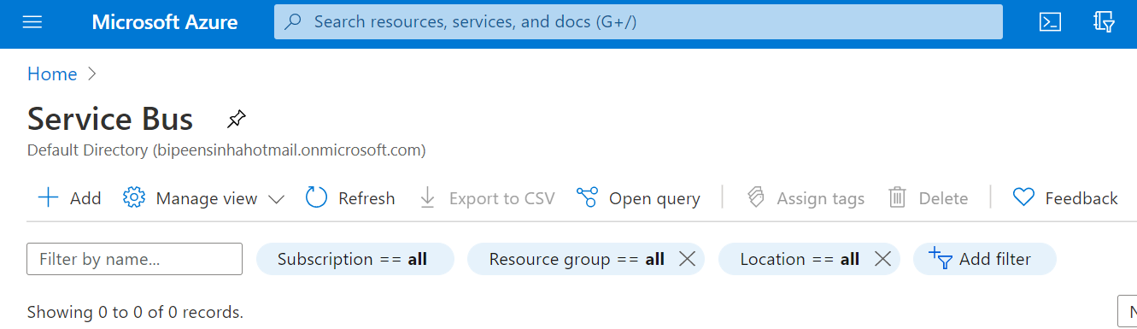

1. In the **Create namespace** dialog

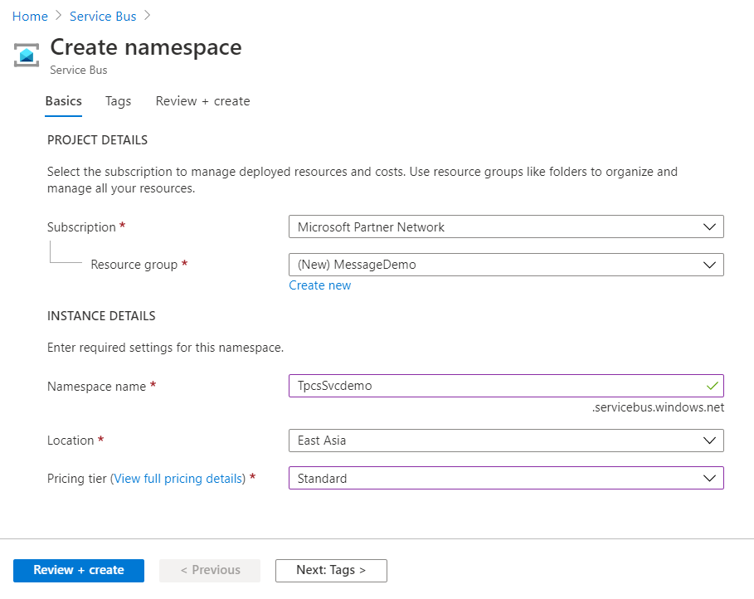

1. Verify the Service Bus get Created

## **Create a queue in the Service Bus**

1. On the **Service Bus Namespace** page, select **Queues** in the left navigational menu.
2. On the **Queues** page, select **+ Queue** on the toolbar.

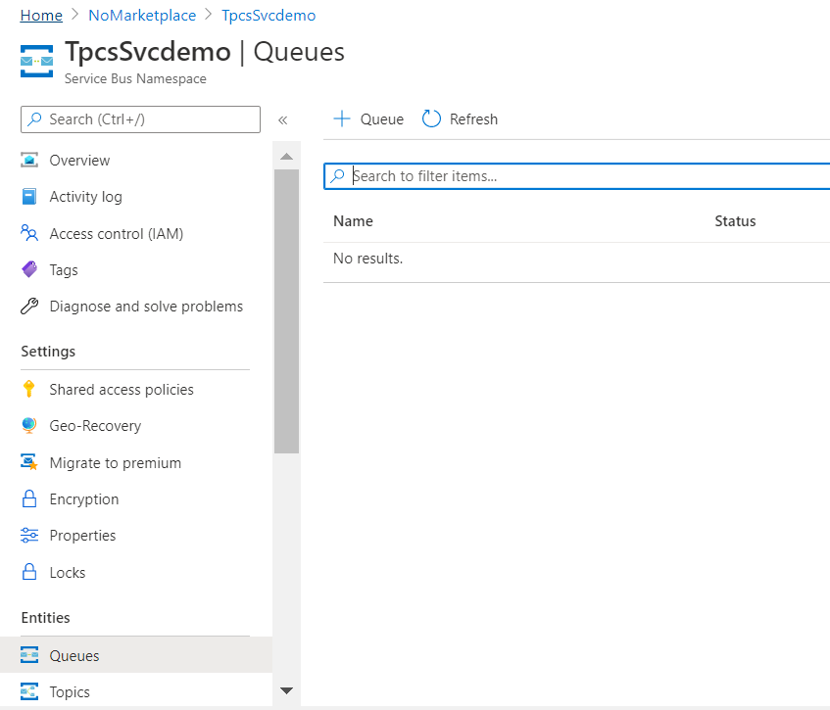

1. Enter a **name** for the queue, and leave the other values with their defaults.
2. Now, select **Create**.

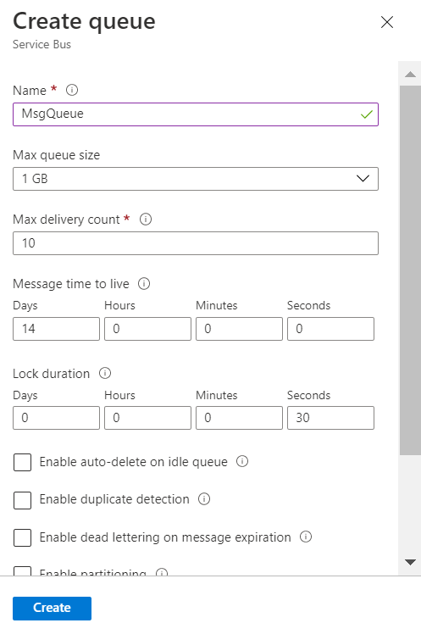

## **Create a Storage Account and Blob Container**

We assume you know how to craete the storage account and container so the deatil steps Ommit here

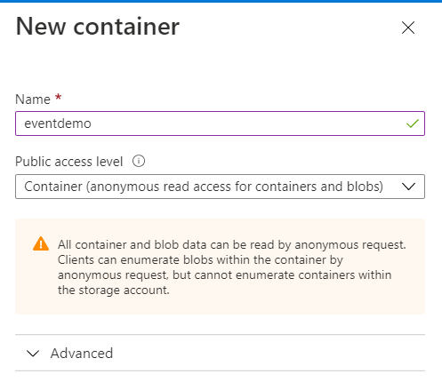

# Setup the Event Subscription

* 1. **Register** the **EventGid service** in Subscription🡪Resource Provider

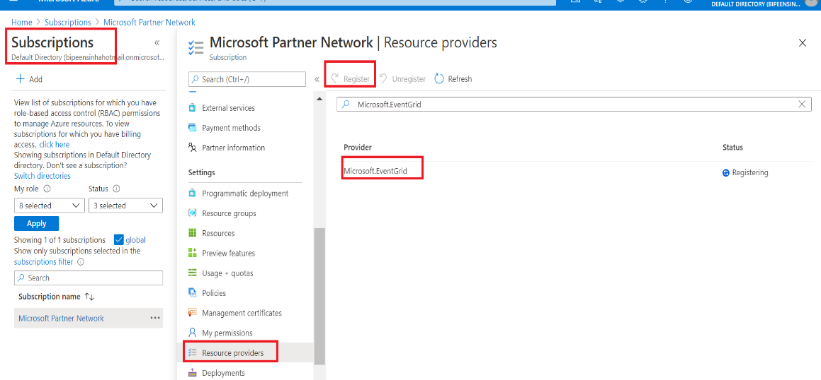

* 1. In Storage Account Select **Events**

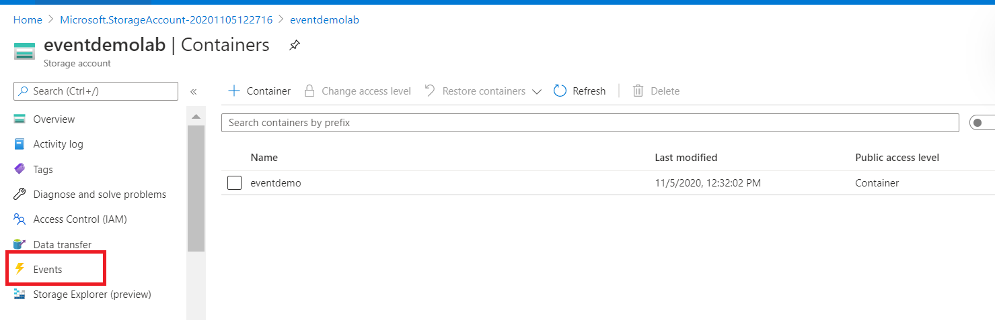

* 1. Click **Event Subscription** and Define Name , Blob Storage , Topic Name, Event Type ( **Blob Created , Blob Deleted).**

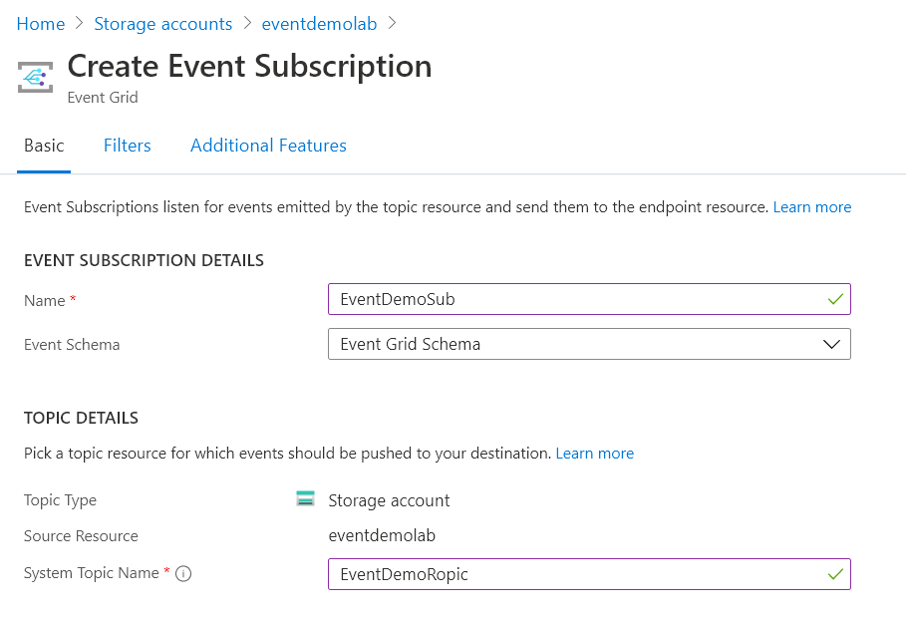

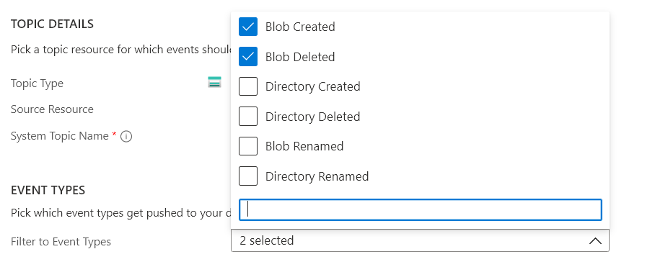

1. In The endpoint details select **Service Bus Queue**

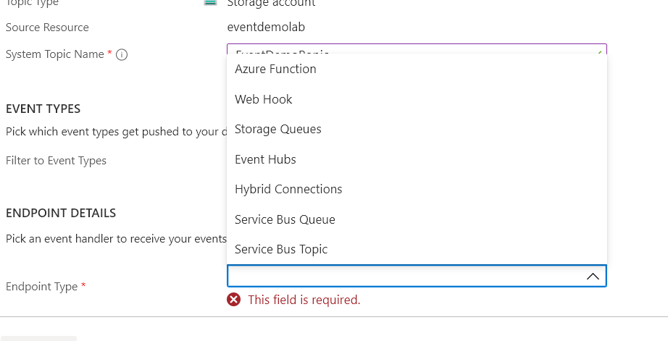

1. In The endpoint details 🡪 Endpoint , select **Service Bus Queue** Name

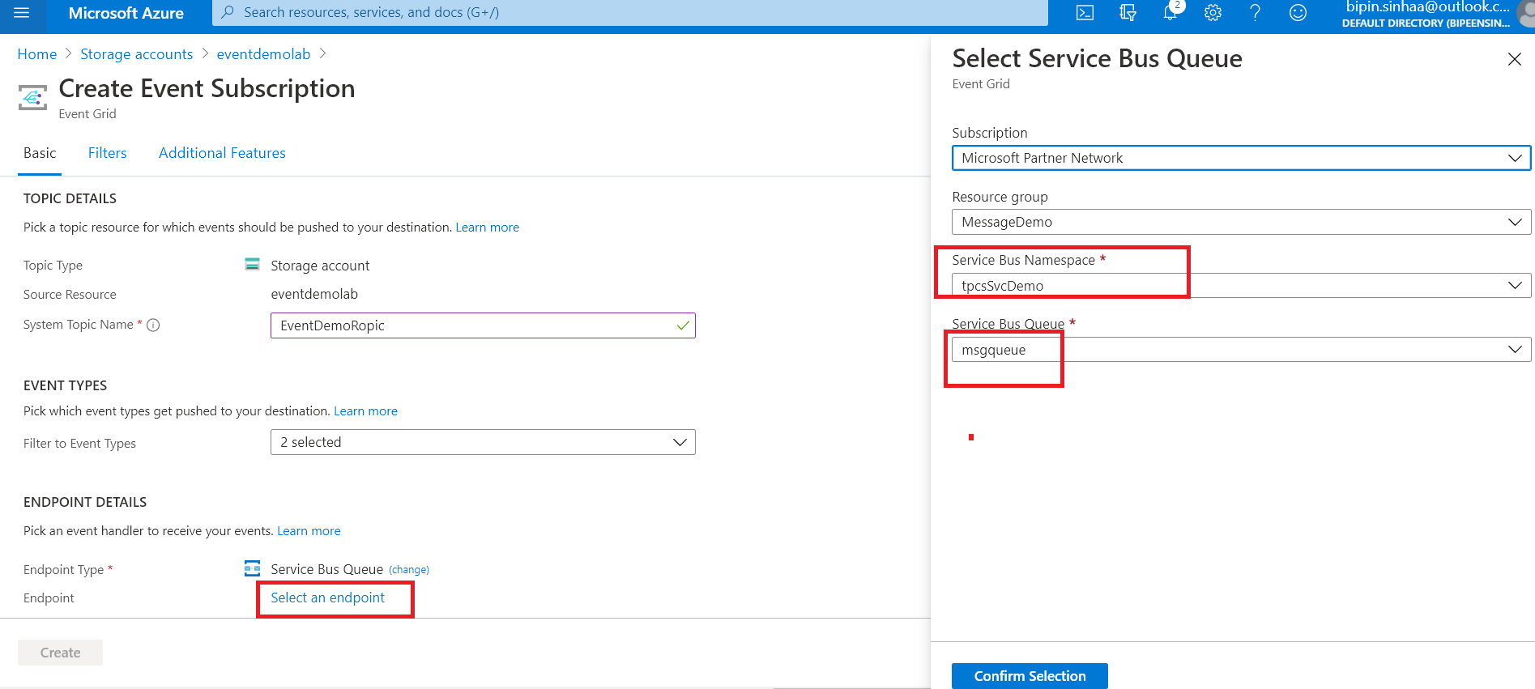

1. Click **Create** to Create the Subscription

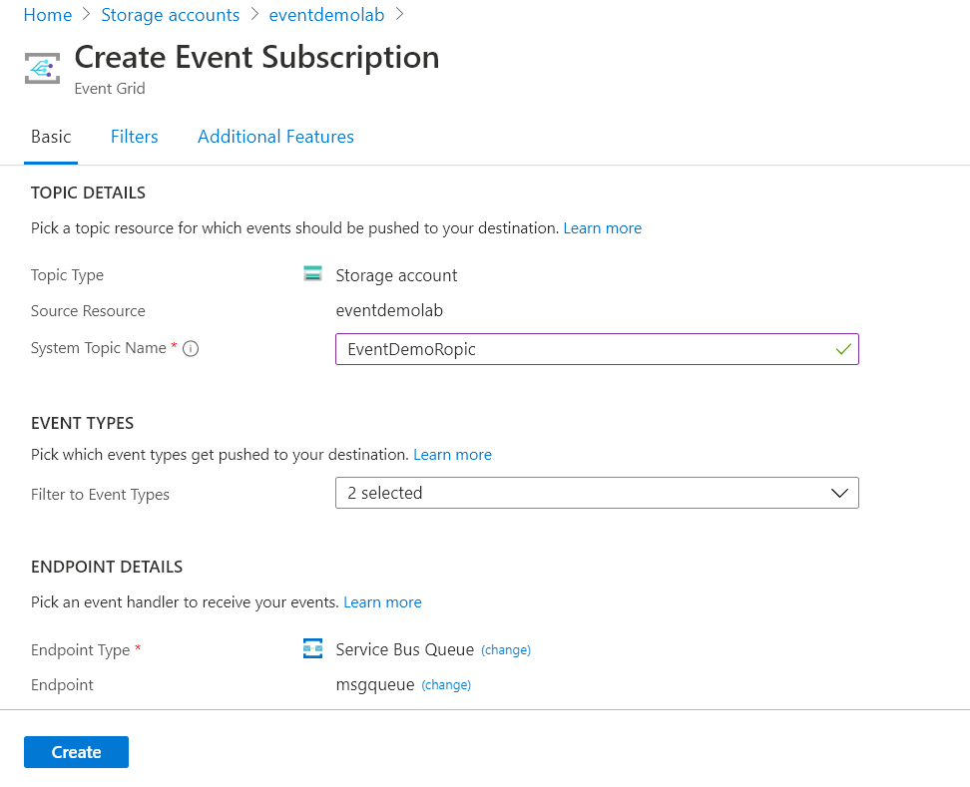

# Trigger the Event with Blob Upload and Delete operation

* 1. Once it created , upload the files in **Blob Container** and also delete few files
  2. Go to **service bus🡪Queue**
  3. **Note the Number of Message in Queue**

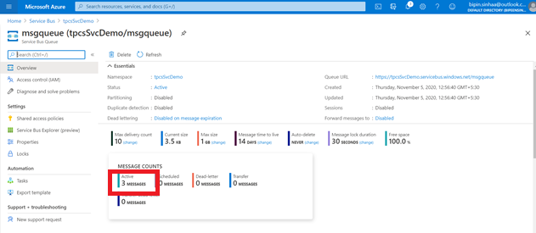

* 1. **Open the Service Bus Explorer to receive the message**

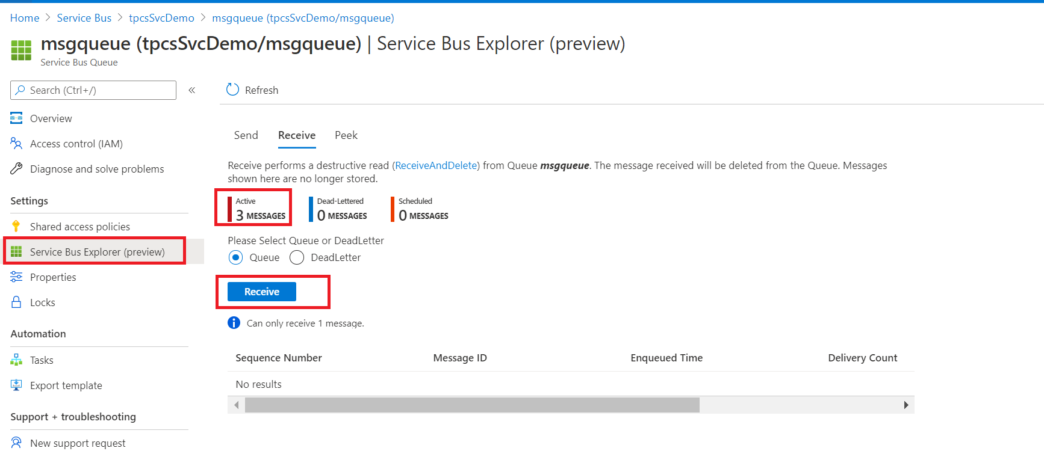

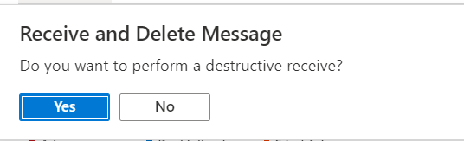

* 1. **Check the message you will notice your file name** which get uploaded an deleted by you

